Rounders England Education Resource
Introduction to Rounders England
Our vision at Rounders England is to ‘connect people through Rounders’ and help everyone to fulfil their potential to realise that ‘We are all Rounders’. Rounders is a cross-generational, cross gender game that embraces all abilities. It is a game that is all about sociability, about connecting with people in an age where screens separate generations and are replacing real and meaningful interactions. A game of Rounders makes great memories, offering an ideal balance between fun and fitness with great opportunities to make friends, get some exercise and have a good laugh! We hope this new and innovative resource, packed full of fun and engaging ideas, will support the development of the physical and mental skills aligned to a striking and fielding team game. Supporting the aspiration for the young people it reaches to create a positive experience of Rounders at school, so that this love can extend into their adulthood and support them to adopt a physically active lifestyle.

Values of Rounders
This resource is underpinned by five core values of Rounders:
- Fair play – learning the importance of rules and being fair to others
- Respect – understanding that everyone has different abilities, and everyone’s contribution is valid, rounders is inclusive
- Teamwork – learning to work together towards a common goal
- Winning behaviours – understanding how to behave towards others and ensuring you are gracious in triumph and defeat
- Fun – to enjoy participating, playing and practising with friends
Each one gets introduced on its own through weekly sessions you deliver, culminating in all of them being encouraged in week six when you play a full game of Rounders. The importance of instilling these values in your young people is vital to ‘connect people through Rounders’ ensuring that the game is fair and fun for all. Values, and the importance of their understanding by your young people will provide transferable life skills that will play out beyond a game of Rounders and support their social and emotional development.

Bringing the values to life
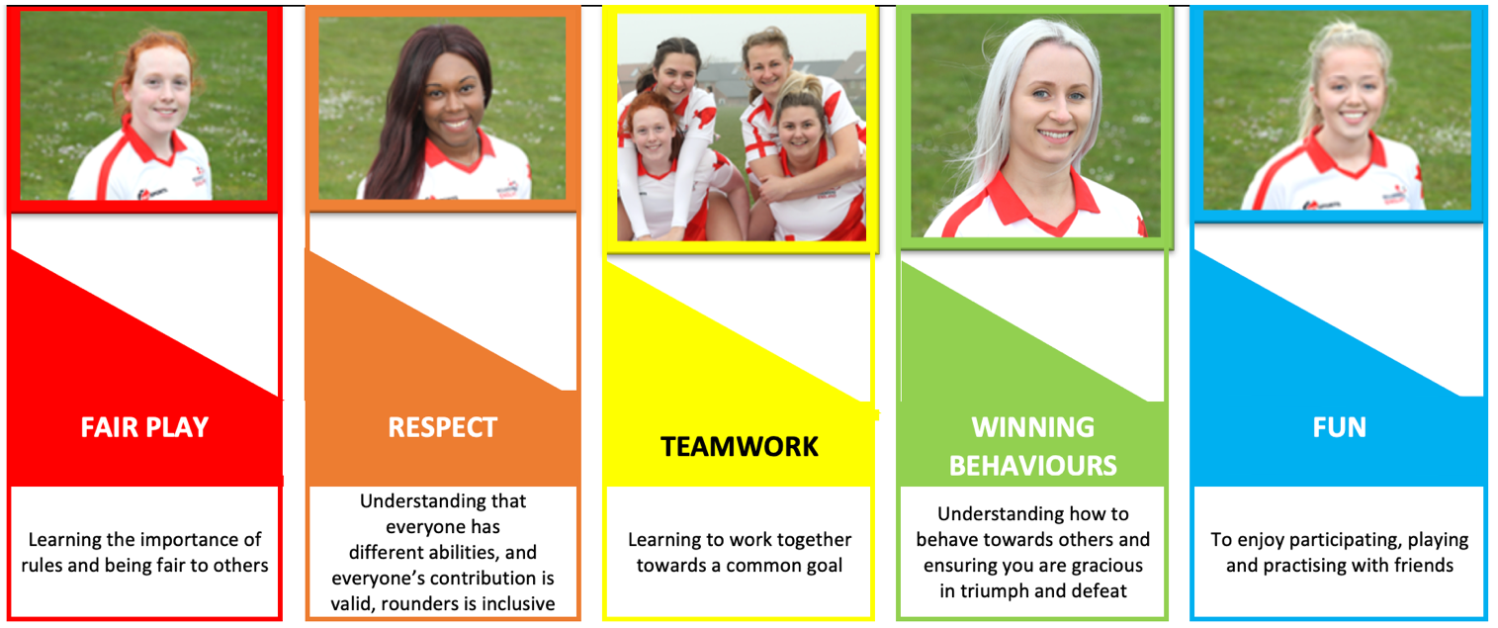
To support the introduction, understanding and importance of our values, we encourage you to appoint a ‘Values Captain’ in each session. Their role is detailed on the resource card and requires reflection at the end to:
- Describe when you have seen this value in action, and how it made you feel?

Ensure the whole class understand the value in focus each lesson and have a full grasp of its understanding and how it can and should be played out.

This activity could be completed alone by the Value Captain, or with their team, or as a whole class activity. It is encouraged that Value Captains are rotated each lesson so that everyone gets to understand the importance and ‘have a go’.

How to use the resource | Differentiation
This resource has been created to provide activity ideas to use during lessons and in after school provision to welcome young people to the sport of Rounders. We have created six sequential resource cards at KS3 that provide a different learning focus, learning outcome, value focus and young person’s goals linked to the striking and fielding PE curriculum.  The format of the cards follows a familiar pattern to support understanding and simplify delivery week after week. Each card sets out the:  - Equipment: required for each session, including substitutions. This should allow you to be best prepared and have everything you need ready from the start.  - Introductory activity: which is relevant to the learning focus and helps you to introduce the young person’s goals, specifically sharing the assessment criteria.  - Activity 1: which provides plenty of practice to achieve the lesson focus, including progressions to extend the challenge or time spent on this part of the session.  - Activity 2: Game: which provides a fun, and competitive format to culminate the session and all that has been practised.  - Reflection: questions that we encourage you to ask your young people as they either cool down or return to class. Each session outlines questions for them to consider on their own, then discuss in a pair, before sharing back to the whole group. These questions link back to the learning focus.  - STEP: At each stage of the session, you will see that we have shared ideas to differentiate the experience based on your young people’s abilities using the STEP principle. To understand this further, please read the section on differentiation. | To ensure all young people can take part and achieve success it is important to consider how adapting activities will make it fair, fun and engaging for all. Using the STEP principle is an easy approach to adapt, differentiate and extend activities within a PE lesson.  - Space – consider where the activity is happening. Changing the size or shape of the space can make things easier or harder.  - Task – consider what is happening. Help your young people to understand the task and rules. Adapt the task by changing the length of time to complete the challenge, giving a head start or changing the number of goes to ensure everyone is having fun.  - Equipment – consider what is being used. Using different equipment can make the activity easier or harder. Think about the size, weight and type of equipment used to keep things varied and suitable for everyone.  - People – consider who is involved. Consider playing with overloaded or underloaded teams, i.e., change the ratio of fielders to batters. Consider matching abilities so that you can differentiate/challenge appropriately.
 | Roles to introduce:
As you deliver the planned sessions, we encourage you to think about the roles your young people could take on in addition to taking part:
- Coach – share the resource card with them, specifically the teaching points that align to the learning focus and assessment criteria (All, Most, Some) encouraging them to use this information to help their peers improve.
- Umpire – give them responsibility to decide what is right and wrong, making decisions that the umpire would about what is a ‘no ball’, or when the ball is struck behind. Ensure they have a good grasp of the rules.
- Scorer – give them responsibility to keep score for their team, or the whole game.
- Team leader – share the resource card with them and ask them to gather the equipment required for the session in advance or set up the warm-up or main activity. In addition, they could be tasked with keeping the space safe, encouraging others to engage and ensure everyone is involved.
- Values Captain – appoint one per team and upskill them on their understanding of the value focus for that session. Encourage them to share their learning with the team and look out for peers who display that value throughout the session.

Ensure roles are rotated each lesson so that everyone gets to ‘have a go’ and understand the importance of certain roles, like Values Captain, Umpire and Scorer. These specific roles can help build confidence and competence. Thus, supporting their social and emotional development.

