SPORTING HERITAGE CIC

CONFIDENTIALITY POLICY

Aim of Policy

SPORTING HERITAGE CIC is committed to maintaining high standards of confidentiality in all aspects of our work. The organisation holds some confidential information. This is provided by, or derived from, voluntary/community organisations, members of the public, third parties and staff.

1. Objectives of Policy

  - To ensure that confidential records are properly managed.

  - To ensure that confidential information is only released in accordance with our Data Protection Policy, legislative considerations, best practice and strict guidelines of the organisation.

  - To ensure that information is only disclosed with the informed consent of the person or organisation to whom the information relates, with the following exceptions:
  - when, by law, we must share information, for example with the Council Tax Office and Inland Revenue;
  - in an emergency, when public safety is at risk and when information is required by the police to prevent or detect crime.

  - To promote a policy that respects commercial sensitivity

- Statement

  - The use of information that SPORTING HERITAGE CIC collects and processes will be used to provide a service or carry out an authorised or requested transaction.

  - SPORTING HERITAGE CIC will not sell, trade, rent or lend confidential information to anyone.

  - SPORTING HERITAGE CIC does use specified information to provide a Directory of Voluntary/Community Organisations where only permitted contact details and essential information to delivering the service will be provided. No confidential individual information will be included.

  - SPORTING HERITAGE CIC may become privy to certain business information, which will be treated in the same confidential manner as person specific information.

2.5 Confidentiality is essential because we recognise:
- The possible consequences for the organisation or individual if it is breached;
- The rights of organisations and individuals to have control over information about them;
- The duties placed on us whereby breaches of confidentiality could lead to formal complaints, grievance or disciplinary actions, or even legal action against us;
- Good practice and our standards for Customer Care.

- Policy Principles

We will:
  - Justify the purpose – Every proposed use or transfer of information will be clearly defined and scrutinised, with continuing uses regularly reviewed by an appropriate guardian.

  - Not give organisation specific data to a third party.

  - Not use person specific information (unless absolutely necessary) – Person specific information will not be used unless there is no alternative.

  - Allow access to information on a strict need to know basis – Only those individuals who need access to organisational, personal and commercially sensitive information will have access to it, and they will only have access to the information items that they need to see.

  - Ensure everyone at SPORTING HERITAGE CIC is aware of their responsibilities – Procedures are in place to ensure that those handling information are aware of their responsibilities and obligations.

  - Understand and comply with the law – SPORTING HERITAGE CIC complies with the Data Protection Act 1998 in processing information. This policy will be reviewed regularly, ensuring that the organisation complies with all legal requirements.

  - Hold all confidential and personal information under secure and restricted conditions within the office.

- Detail

The three main principles of the confidentiality policy are “informed consent”, “need to know” and “third party disclosure”. These principles apply both to members of the public and to members of staff.

4.1 Informed Consent
- Disclosure of personal information will only take place with the informed consent of that person. For consent to be informed, we will tell the member of the public/staff why there is a need to share information, with whom it will be shared and the likely consequences of agreeing or not agreeing to disclosure.

- We will state clearly that the information given may need to be shared with others in order to be able to provide the service requested and that non-disclosure could mean that a person would not gain access to a service or to support to which they might otherwise have been entitled.
- We will inform members of the public of our Confidentiality Policy at the first point of contact and ask them to give their consent to permit the passing on of any personal information given, if necessary, on a “need to know” basis.

4.2 Need to Know
- The transfer of personal information relating to a member of the public/staff will be kept to a minimum on a “need to know” basis. Only those staff or other service providers who have a need to know, in order to provide relevant services, will share information and only after informed consent has been given.

4.3 Disclosure to Third Parties
- Personal information will only be disclosed to third parties with the express, written or oral, consent of the person(s) who is (are) the data subject(s). Disclosure will only be considered, and consent sought, where there are clear reasons why this should happen.
- We will ensure that the recipient understands the need for confidentiality and that disclosure only takes place on the terms agreed with the person it concerns.
- On any occasion when confidential information is provided by way of a written or an oral response, we will state that the information provided is CONFIDENTIAL and should be respected as such.

5. Procedure for Dealing with Breaches of this Policy

Any breach of this policy, intended or accidental, is not acceptable. Infringements of this policy will be dealt with seriously as disciplinary matter under SPORTING HERITAGE CIC’s normal disciplinary procedures and may involve either informal or formal action depending on the seriousness of the case.

The Policy in Practice

 | 1. |  | A client’s visit or telephone call to the Orchard or Services is completely CONFIDENTIAL. Information is only ever shared on a ‘need to know’ basis see 4.2. This is the case regardless as to whether the person in question is known to us or not, or of who is enquiring. In quoting confidentiality, staff use the following statement:
 | 1.1 |  | “SPORTING HERITAGE CIC operates a policy of confidentiality and I can therefore neither confirm nor deny that this person is known to SPORTING HERITAGE CIC. However, I can take a message and, should this person contact the Centre I will pass this message on to them.”
 |  | - Details of counselling sessions or other support sessions are confidential to the staff team. Such information will not be passed on to any third party, without exception unless the client concerned specifically requests this to be so.
3. |  | Information discussed during meetings where third parties may be present should be treated with the same level of confidentiality, with the exception that the third party signs a Confidentiality for Visitors form prior to the meeting and receives at the same time SPORTING HERITAGE CIC Policy on Confidentiality and Policy on Disclosure of Information. Third parties may include other health professionals, workers or managers from other agencies with whom SPORTING HERITAGE CIC shares or is likely to share clients, students undertaking work placement or visiting students in the course of their training, volunteers of SPORTING HERITAGE CIC, other legitimate visitors working with or connected professionally to clients of SPORTING HERITAGE CIC.
4. |  | CONFIDENTIALITY WILL ONLY BE BREACHED IN THE FOLLOWING CIRCUMSTANCES:
4.1 |  | In certain circumstances SPORTING HERITAGE CIC is legally and ethically obliged to say whether or not a client is known to SPORTING HERITAGE CIC or is at, or has recently visited, the Orchard/service. Example: (i) where police have reasonable suspicion that a person they believe has contacted the Orchard/Service is connected with a crime currently under investigation (ii) where a client discloses a violent history partner agencies shall be notified. (See Serious (Violent) and sex Offender Policy).
4.2 |  | SPORTING HERITAGE CIC works in accordance with Safeguarding Children and Vulnerable Adults and will share information according to these policies. Any concerns regarding child or vulnerable adult protection shall be bought to the attention of management or the Children and Families specialist, for their immediate action.
4.3 |  | Where a young person under 16 has been reported missing to the police, staff will disclose whether or not that client has recently contacted the Orchard/Service to the police but not to a parent (in case this puts the child at risk).
4.4 |  | The policy on confidentiality exists to protect the client. In certain circumstances keeping confidentiality may result in harm to a client (or other person). Staff must bring all concerns to management for appropriate course of action to be agreed.
4.5 |  | All concerns and action regarding the necessary breach of confidentiality shall be recorded in the daily log book and client file. (See Procedure for writing in the Log and Data Protection Policy).
5. |  | Partnership working
5.1 |  | SPORTING HERITAGE CIC is committed to partnership working for the benefit of its clients. Joint working protocols should be agreed and signed by appropriate people to allow the appropriate sharing of pertinent information to reduce the risk of potential harm to a person.

Equality and Diversity
We aim to be an organisation that values, recognises and responds to the diverse needs of members and those we serve. We adhere to the Equality Act 2010 and will not discriminate against any person or other organisation with particular reference to the protected characteristics
Monitoring and Review
The Senior Management Team, with adequate consultation of the Board of Trustees, will regularly review the operation of this policy.

Agreed by SPORTING HERITAGE CIC
Signature 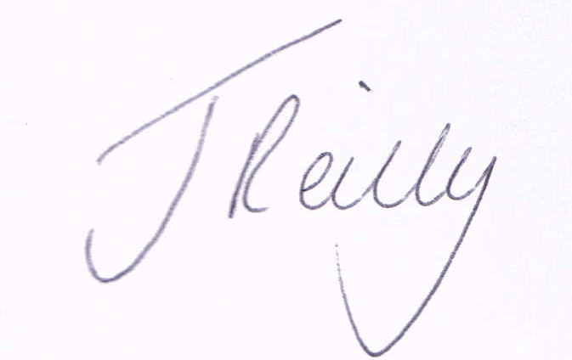 | Date: 5th May 2020

