**National Sporting Heritage Day and Schools**

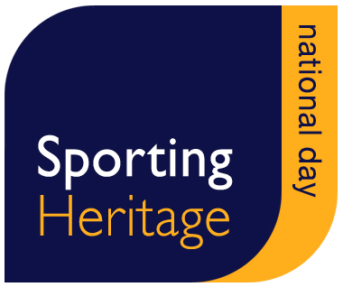

This information sheet offers suggestions for how schools and other learning providers may wish to engage in the National Sporting Heritage Day, and use sporting heritage more generally within teaching and learning. Involvement in the National Sporting Heritage Day will engage schools with wider sectors of their community and allow them to celebrate the local sporting past in new, exciting and creative ways.



Although National Sporting Heritage Day takes place on the 30thSeptember, you do not need to limit your activity to this day alone. You will probably want to spend time developing your project, and perhaps use the day itself as an opportunity to share your programme with others, or involve new people in your work.

**What is Sporting Heritage?**

Sporting Heritage includes all of the amazing objects, stories, documents, photographs and film that tell the story of the sporting past.

**Why is Sporting Heritage important for schools?**

“It engages and stimulates the children, making history purposeful, relevant and interesting for them”. Head-teacher, Bradford.

Sporting heritage sparks the imagination of people across class, gender and cultural backgrounds. It directly links to the new national curriculum and engages children and young people in understanding cross-curricula subjects as diverse as History, English, and Computing.

**How Sporting Heritage can support teaching and learning**

**Inspiring pupils to learn:** Sporting heritage inspires children in their learning, making a particular difference to under-achieving children. Its many links to social history, combined with the scientific, aesthetic and numerical aspects of sport, lend themselves to cross-curricular learning.

**Intergenerational opportunities:** Sporting heritage bridges the generation gap. The subject often allows children and young people to understand more about older generations and vice versa for the first time.

**Community development:** Sporting heritage supports a greater understanding of different communities and cultures through the universal language of sport, often through increasing knowledge and understanding of local communities.

**Opportunities to commemorate World War 1:** This year’s theme is WW1, and provides an opportunity for schools to link the two themes. In addition to the experiences of sportsmen at war, sport was at the heart of recruitment and controversies about the role of leisure in wartime, and helped to maintain morale at the front.

**Mapping to the national curriculum at the four key stages**

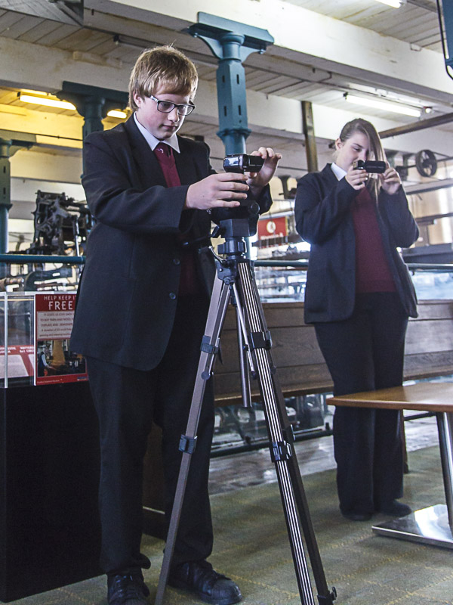

The following section provides some example opportunities which could be used by schools to celebrate the local sporting past and commemorate WW1, whilst ensuring strong links are made to the new National Curriculum. The information here is not exhaustive, but aims to provide a taster of the type of opportunities available using the topic of sporting heritage within the classroom. The ideas listed below for specific keys stages, could also be adapted for other key stages or whole school development weeks.

**The ideas below link to WW1, but you could take any theme as a backdrop to your learning planning.**

**Inquiry Topic: How did World War One inspire the creation of the game of darts?**

|  |  |  |  |
| --- | --- | --- | --- |
| Curriculum Links | Learning objectives | Key Stage | Suggested activities |
| English  History  Science  Art and Design  Design and technolog1y  Computing  Maths  Citizenship  PSHE | * To compare and contrast the differences between WW1 and today * To use WW1 and sport as the inspiration to explore cross-curricula subject areas * To understand the fragility of life during war * To empathise with soldiers who fought and returned from war * To understand the coping mechanisms used by soldiers during war-time * To understand how war plays a part in the development of technology | 1 & 2  1 & 2  2  2, 3 & 4 | * Research trench art. What was it? What else did soldiers make and why? Look at toys made during WW1 in the trenches. How are these similar from our toys? What toys were girls and boys playing with during WW1? How do we know? * Create your own sports games and equipment / toys to play during a class event * Watch a video about life in the trenches – discuss why the soldiers might have decided to make the darts? How would they have made them? What tools did they use? How is this different from today? * Research other discoveries that took place as a result of WW1 and discuss what life would be like without them * A soldier went on to patent darts. Set up a “dragons den” scenario using the darts situation as inspiration. Learn about patents, work as a team, and develop a business model. * Create your own (suction!) darts set. Understand the science behind creating a dart and how to make it fly successfully. * Host a suction darts championship in class * Measure the distance the darts fly, compare and contrast with other objects   <http://www.mylearning.org/wwi-shells-inspire-the-game-of-darts/p-4543/>) |

**Inquiry Topic: What sports did children and young people play during World War 1?**

|  |  |  |  |
| --- | --- | --- | --- |
| Curriculum Links | Learning Aims and objectives | Key Stage | Suggested activities |
| History  English  Art and design  Computing  PE  Citizenship  PSHE | * To understand the differences and similarities between the early 20th century, war-time and today * To empathise with children and young people during war-time * To understand the differences between opportunities for girls and boys in the past in comparison to today * To understand the effect of war on local communities | 1, 2, 3 & 4    1 & 2  1 & 2  2 & 3  2 ,3 ,& 4 | * Research WW1 sports and activities played in school. Discuss how these are different from today. * Hold a sports day playing sport that children and young people would have played during WW1 – make posters to advertise it, make costumes, find out about the distances used etc. * Imagine you are a child in 1914, write a story about your favourite sport * Watch a film about children in WW1. How do you think children and young people felt at the beginning of WW1? What was happening to the men in their community? How did this affect their communities? * Do you know the local sports clubs in your area? What effect do you think WW1 had on your own local community? |

**Inquiry topic: Who was Ronnie Poulton? (**Ronnie Poulton was the England Rugby Team Captain at the time he went to war)

Another sports person who fought in the war would be just as relevant, for example a figure from a local sports club. There are also examples of whole teams leaving for the war, for example Hearts football club from Scotland.

|  |  |  |  |
| --- | --- | --- | --- |
| Curriculum Links | Learning Aims and objectives | Key Stage | Suggested activities |
| English  History  ICT  Citizenship  PSHE  Music | * To explore a range of curriculum subjects using a central figure from history as inspiration * An understanding that war effected everybody – no-one was immune * Comparisons between sports men and women and others at war * An understanding of the individual in the field of war | 1, 2, 3, & 4  1,2,3, & 4  1 & 2  2, 3, & 4  2, 3, & 4  2, 3, & 4  2, 3, & 4  2, 3, & 4 | * Research Ronnie Poulton and find out where he came from, when he was born, how old he was when he went to war etc. * Write a poem about how he would have felt going to war * Create a rugby ball using a range of different media * Imagine an England sports captain was called up to fight in a war today, write a diary about their first week at war * Write a newspaper article announcing that Ronnie will be going to fight in the war * Compose a song about Ronnie * Work in teams to film a short interview with “Ronnie”. What questions will you ask? What answers would he give? * Find out about other sports men and women who went to war – how prevalent was this? How do you think it effected sport in the UK? |

**Inquiry topic: Was sport important during World War 1?**

|  |  |  |  |
| --- | --- | --- | --- |
| Curriculum Links | Learning Aims and objectives | Key Stage | Suggested activities |
| English  History  Computing  Citizenship  PSHE | * To explore the comparative issues of sport and war * To understand the cause and effect of one event on another * To understand the pressures of war on ordinary people * To develop an empathy with those who fought during the war * To understand the role of sport in providing hope, camaraderie, and crossing the barriers of race | 1,2,3 & 4  1,2,3 & 4  2, 3, & 4  2, 3, & 4  2, 3, & 4  2, 3, & 4  2, 3, & 4 | * Research the Christmas Day Truce. Discuss why the soldiers played a football match. How would they have been feeling? Imagine you were a soldier in WW1, and write a letter home about the match. * Was it possible to play sport during WW1? What were the barriers to competitive sport at home? What were the barriers for those in the trenches? Bring in issues of genders, geography, and equipment at later key stages * Read poetry created in WW1 (download from our website) about sport and war. Discuss what the soldiers were thinking. How do they use references to sport to illustrate how they are feeling? * Imagine you are a soldier in WW1, write a poem about how you feel using references about sport * Write and record a short audio commentary of the WW1 truce * Research how sport is used today to bridge boundaries of race etc. Create a poster about a sports match to increase awareness of one issue * Visit a local museum to look at their WW1 images and objects. How are these relevant to the soldiers who played in the WW1 matches? How would they have used them? Are they in any of the pictures? |

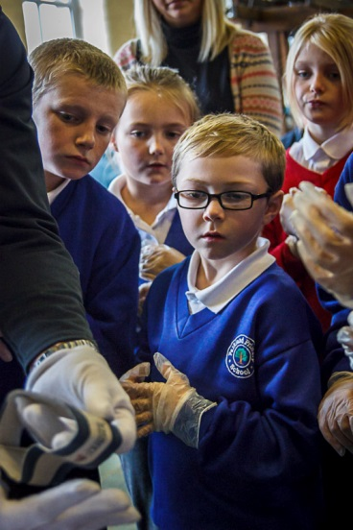

Keep in touch!

Don’t forget to let us know about any events you organise, or about how use are supporting the National Sporting Heritage Day!

**Email:** [**justine@sportingheritage.org.uk**](mailto:justine@sportingheritage.org.uk)

**Twitter: @sportinghistory**